Contact: Bonita Cutliff  University Museum  Texas Southern University  3100 Cleburne Ave Houston, TX 77004  Phone: (713) 313-7145  Fax : (713) 313-7342  Email: cutliffb@tsu.edu |  | University Museum  Texas Southern University

Press Release
Houston, Texas April 11, 2014: The University Museum presents Playing by Dragon Rule. This exhibition features two artists Abidemi Olowonira and Gregory Michael Carter who have lived in China and Japan respectively, partaking in a dialogue that showcases their experiences and recollections of their journeys, they intend to create a dialogue that transcends real and imagined identities and boundaries.
The exhibit explores interactions between transcultural and migratory models with a focus on the evocative aspects of the exchange. Works in this exhibition are a mere chapter in the on-going narrative of these artists.
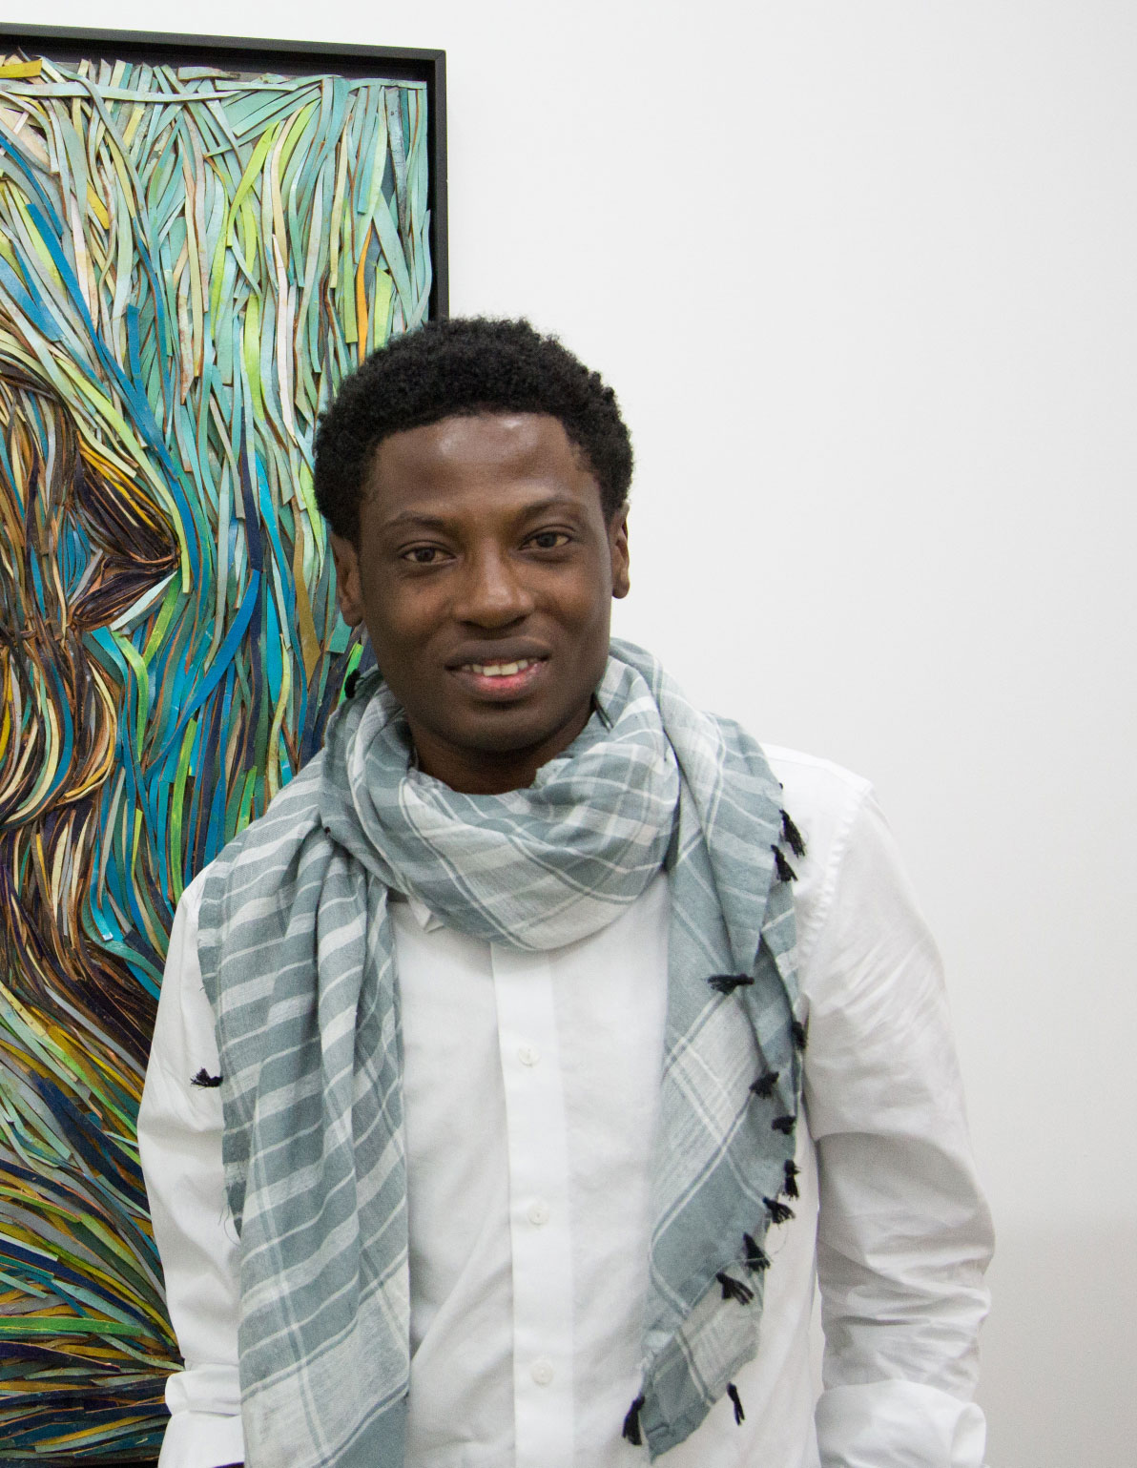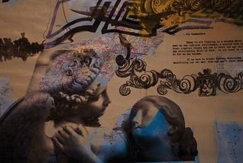
About the Artists:
Abidemi Olowonira was born in Ibadan, Nigeria February 25, 1983. He contracted Polio when he was one year old while his parents were in the United States pursuing their higher studies. His grandmother raised him in Lagos through his adolescent and teenage years. She was a pottery maker and had a great influence on Abidemi.
His passion for art budded as a child in Lagos, where he began drawing paintings of his neighbors and friends for money. His fascination with African art, the vibrant colors and sophisticated patterns that characterized it continue to serve as a frame of reference in his creative endeavors.
In 2002, he relocated to Houston, Texas where he reunited with his family. Abidemi enrolled at the John T. Biggers School of Art at Texas Southern University. At TSU, Abidemi was reintroduced to his African aesthetics from an academic and artistic standpoint, which impacted the development of his expressive style, which he describes as a form of storytelling. In 2003, he began exhibiting his art and for the first time received an award for his works at Texas Southern University. In 2008, He was a featured artist in the 12th Annual Citywide African American Art Exhibition sponsored by the Houston Museum of Fine Arts. It was the same year he met Chicago based visual artist, Abiola Akintola who would become his mentor and protégé. In December of the same year, he earned a BFA from Texas Southern University. Abidemi’s art has been displayed at the JP Morgan Chase Tower, Contemporary Arts Museum, the Museum of Cultural Arts, and at Rice University.
In 2010 Abidemi traveled to China with Abiola Akintola, as the first group of Black artists to ever create works for the opening of the Asian Olympic Games in Guangzhou, China. While in China, he also worked with the famous Chinese sculptor, Xu Hong Fei. In 2011 Abidemi was the recipient of the US China Business Association Art Exchange residency program in Shanghai, a one year long residency. In 2012, he was a Tashkeel Artist in Residence in the 2012 Art Dubai. Abidemi is currently pursuing his MFA at Houston Baptist University and continues to work on art projects, commissions, and exhibitions around the United States.

Major Sponsors are Tina Knowles, The Reginald Van Lee Foundation, Atwood Oceanics, HEB. Additional Support has been provided by Wendy Adair; Julie and Francois Blais; Annette and Arthur Bracey; Angelique and Garnet Coleman; Tanya and James Douglas; High Fashion; I.W. Marks; International Connections of Houston, Anna Taylor James; Sharon Jones and Shayla Jones-Brook; Lemond Catering; Paul Mitchell, The School; Horace Moaning; National Oilwell Varco; Page Parkes Models, Phenon Finley-Smiley; Joy and Darrell Fitzgerald; Apple and John Gidley; Irene and Ronald Johnson; President and Mrs.John Rudley; The Volunteer Circle of the University Musuem; Wade Wilson Art and Toni Whitaker.

Hours & Admission
Admission is free, however donation are always welcome.
Tuesday – Friday: 10am – 5pm
Saturday – Sunday: 12pm – 5pm
The museum is closed on Mondays and national holidays, located in the south wing of the Fairchild building on the campus of Texas Southern University.

Docent Tours
Special docent led tours for children; student and adult groups are organized by docent coordinator. To reserve a tour please contact Chrystal Robinson-Davis at 713.313.7120.

Museum Parking and Directions
Limited parking in Lot A & Lot L is available on Saturdays and Sundays. Parking is always available at the parking garage on the corner of Blodgett and Ennis, all museum visitors receive validated parking.

59 South
To reach the museum via 59 South, take hwy 288 South and exit on Southmore Street. Turn left onto Southmore, and continue until Ennis Street, make a left onto Ennis Street. Continue on Ennis and cross the light at Blodgett Street. The parking garage is located on the left immediately after the Blodgett light.

59 North
To reach the museum via 59 North, take hwy 288 South and exit on Southmore Street. Turn left onto Southmore, and continue until Ennis Street, make a left onto Ennis Street. Continue on Ennis and cross the light at Blodgett Street. The parking garage is located on the left immediately after the Blodgett light.

45 South
To reach the museum via 45 South. Take the Scott Street exit, and then make a left onto Scott Street. Continue on Scott until Blodgett Street. Make a right onto Blodgett Street; continue on Blodgett, parking garage will be located on the right, immediately before the Ennis Street light.

45 North
To reach the museum via 45 North, Take the Scott Street exit, and then make a right onto Scott Street. Continue on Scott until Blodgett Street. Make a right onto Blodgett Street; continue on Blodgett, parking garage will be located on the right, immediately before the Ennis Street light.

